|  |
| --- |
| PS2Win |
| Weekly Report |
| Keep Your Time |

|  |
| --- |
| Carla Machado  23-02-2013 |

**Team Members:**

Carla Machado

David João

Filipe Brandão

João Girão

João Martins

Mário Oliveira

Rui Ganhoto

**Week 1**, 18th of February to 25th of February

Content

1. Week Activities 1

1.1. Work Executed 1

1.2. Achievements 1

2. Impediments 1

3. Plans For Next Week 1

4. Progress 2

4.1. Earned value and/or Gantt Image 2

4.2. Effort by task 2

4.3. Individual effort 3

5. Individual log 3

**Images**

Figure 1: Earned Value 2

Figure 2: Effort by task chart 2

Figure 3: Individual effort chart 3

**Tables**

Table 1: List of Contribuitors ii

Table 2: Version history ii

Table 3: Log of individual effort 3

|  |  |  |  |
| --- | --- | --- | --- |
| **Authors and Contributors** | | | |
| **Date** | **Name** | **Contacts** | **Contribution** |
| 23-02-2013 | Carla Machado | a21170460@alunos.isec.pt | Author |
| 24-02-2013 | Filipe Brandão | a21180276@alunos.isec.pt | Contributor |
|  |  |  |  |
|  |  |  |  |

Table : List of Contribuitors

|  |  |  |  |  |  |
| --- | --- | --- | --- | --- | --- |
| **Revision History** | | | | | |
| **Date** | **Description** | **Author** | **Version** | **Approvers** | **State** |
| 23-02-2013 | Creation of first draft | Carla Machado | 0.1 |  | Draft |
| 24-02-2013 | Filled work executed, achievements ,impediments and plans for next week. | Filipe Brandão | 0.2 |  | Draft |
| 25-02-2013 | Added charts and individual tasks | Filipe Brandão | 0.3 |  | Draft |
| 25-02-2013 | Document revision | Carla Machado | 0.4 |  | Draft |
| 08-03-2013 | Adding Project and Team Name. Ready for Revision | Carla Machado | 0.5 |  | Ready for Revision |
| 08-03-2013 | Document reviewed | Mário Oliveira | 0.5 |  | Ready for Revision |
|  |  |  |  |  |  |
|  |  |  |  |  |  |
|  |  |  |  |  |  |
|  |  |  |  |  |  |
|  |  |  |  |  |  |

Table 2: Version history

# Week Activities

# Work Executed

* Study processes (CMMI, ISO/IEC 12207)
* List the processes we will need, and when we will need them
* Plan the processes design
* Define the Documents Management process
* Prepare the dashboard
* Prepare the documents repository
* Prepare team and individual logs plus time records

# Achievements

Documents Management Process produced.

# Impediments

None identified.

# Plans For Next Week

Move logs from Google Docs to SVN repository.

# Progress

# Earned value and/or Gantt Image

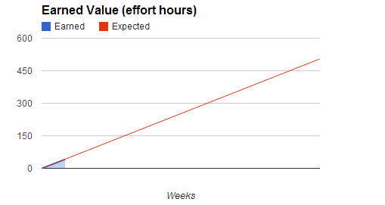

Figure 1: Earned Value

Expected = 42 hours

Earned = 41.5 hours

# Effort by task

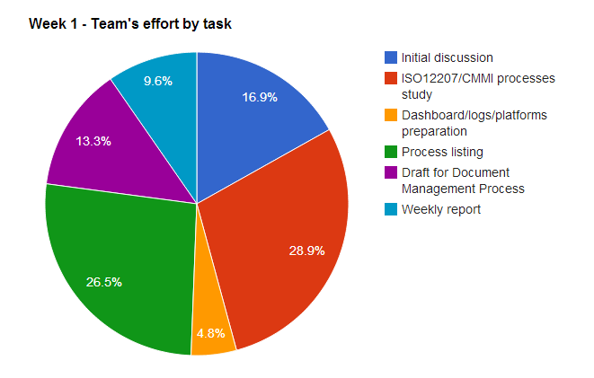

Figure 2: Effort by task chart

# Individual effort

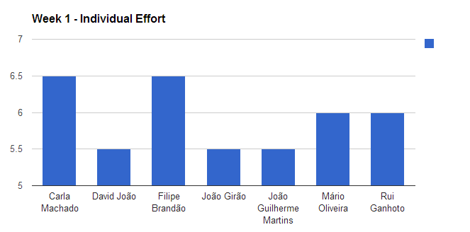

Figure 3: Individual effort chart

|  |  |
| --- | --- |
| **Team member** | **Total effort (hours)** |
| Carla Machado | 6.5 |
| David João | 5.5 |
| Filipe Brandão | 6.5 |
| João Girão | 5.5 |
| João Guilherme Martins | 5.5 |
| Mário Oliveira | 6 |
| Rui Ganhoto | 6 |

Table 3: Log of individual effort

# Individual log

**Carla Machado - Tasks done:**

* Initial discussion
* Creating document templates
  + Basic template
  + Processes template
  + Weekly Report template
* Listing of the needed processes
* Creating draft of the document management process

**David João - Tasks done:**

* Initial discussion.
* ISO12207 processes study, with focus in particular details.
* Listing of the needed processes.
* Weekly report.

**Filipe Brandão - Tasks done:**

* Initial discussion
* Dashboard, logs and burndownchart preparation.
* ISO12207 processes study.
* Listing of the needed processes.
* Weekly report.

**João Girão - Tasks done:**

* Initial discussion.
* ISO12207 processes study.
* Listing of the needed processes.
* Create document "Processes List"; Organize Repository SVN; Update Dashboard

**João Martins - Tasks done:**

* Initial discussion.
* CMMI processes study.
* Listing of the needed processes.
* Weekly report.

**Mário Oliveira - Tasks done:**

* Initial discussion.
* Creating Document templates (Drafts)
* ISO12207 processes study.
* Listing of the needed processes.
* Weekly report.
* Creating Draft Document Management Process

**Rui Ganhoto - Tasks done:**

* Initial discussion.
* Documents and code repository creation
* ISO12207 processes study.
* Listing of the needed processes.
* Group platform creation for better communication
* Weekly Report